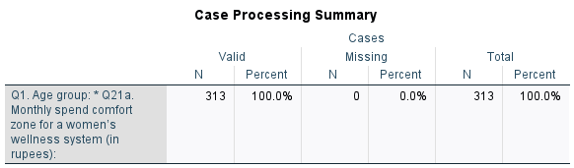

Cross Tabulation: Age x Spending Capacity
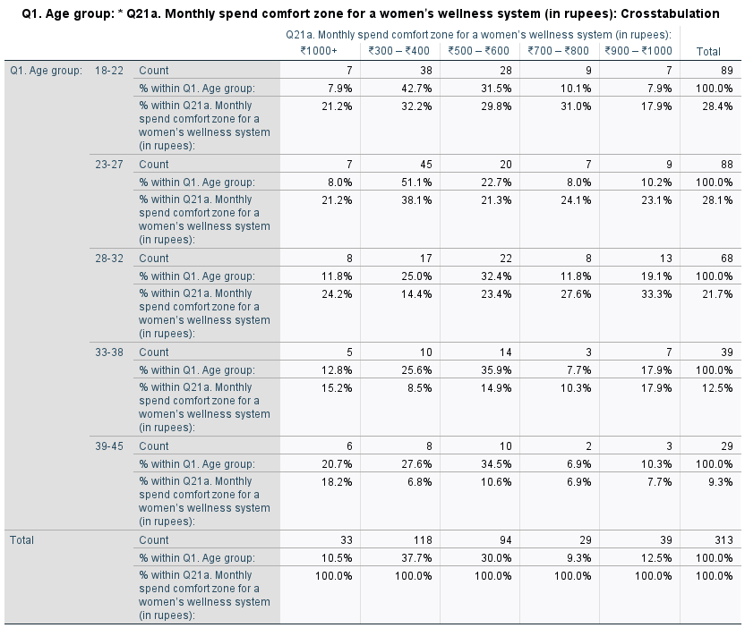

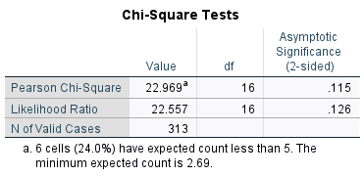
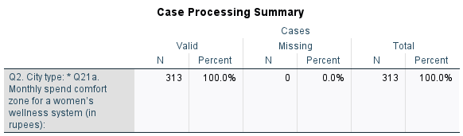
Cross Tabulation: City x Spending Capacity

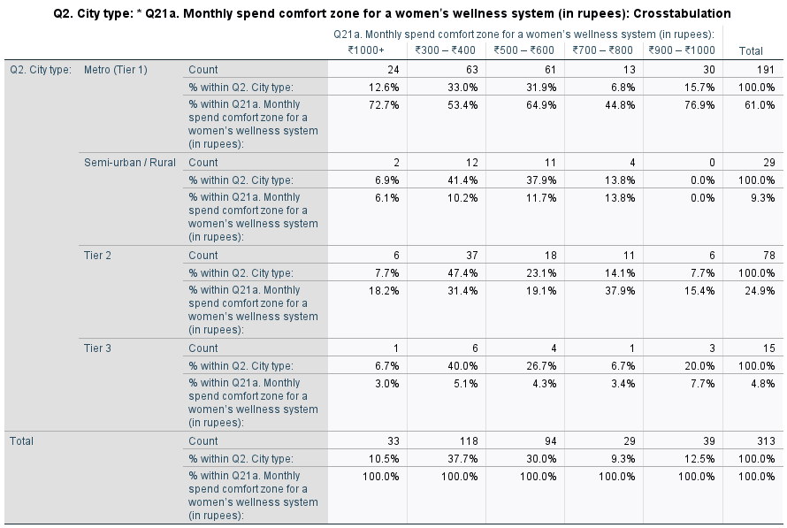
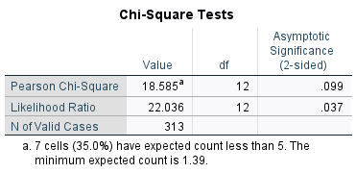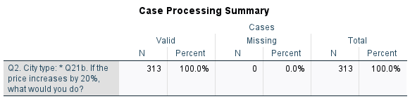

Cross Tabulation: City Type X willingness to pay extra

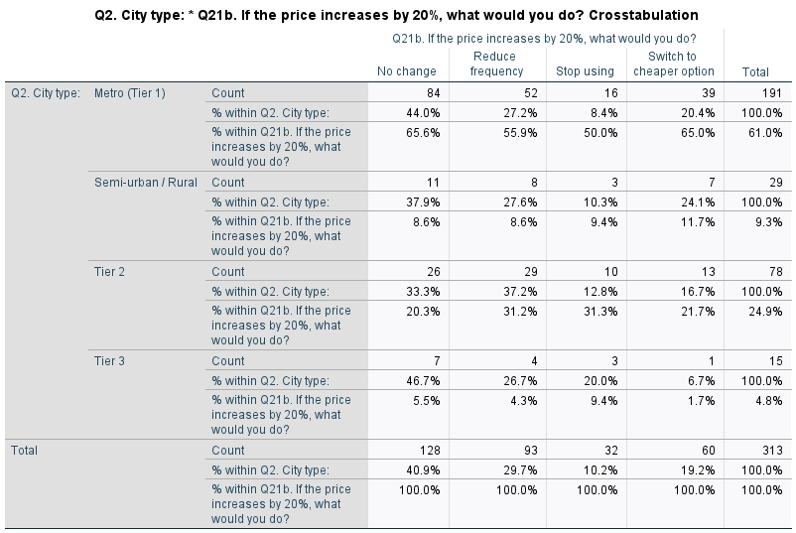
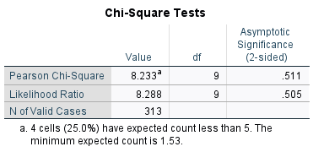

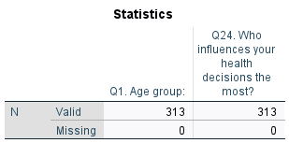

Frequency Distribution: Age Group

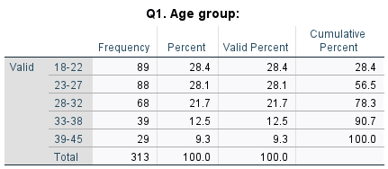

Frequency Distribution: Decision influence

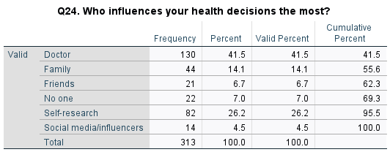
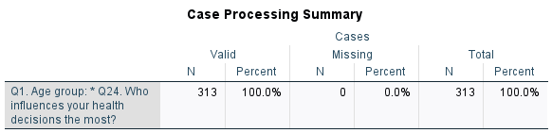

Cross Tabulation: Age group x Influence Decision

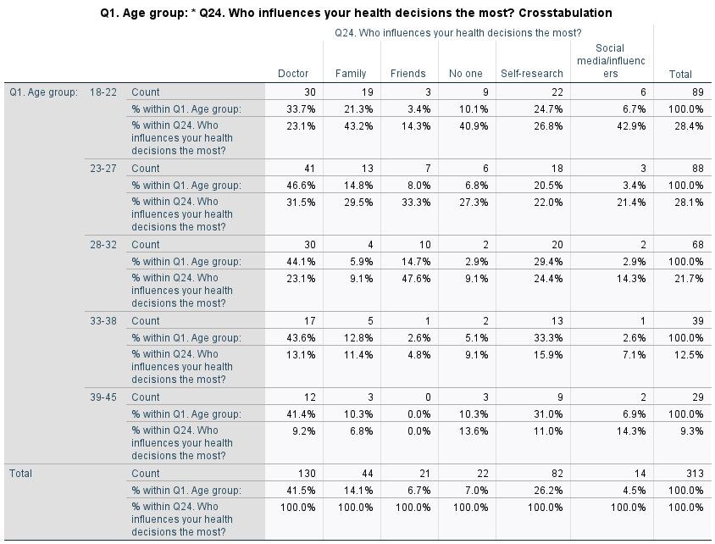
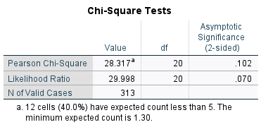
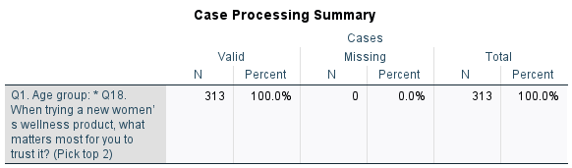

Cross Tabulation: Age Group X Trust Factor

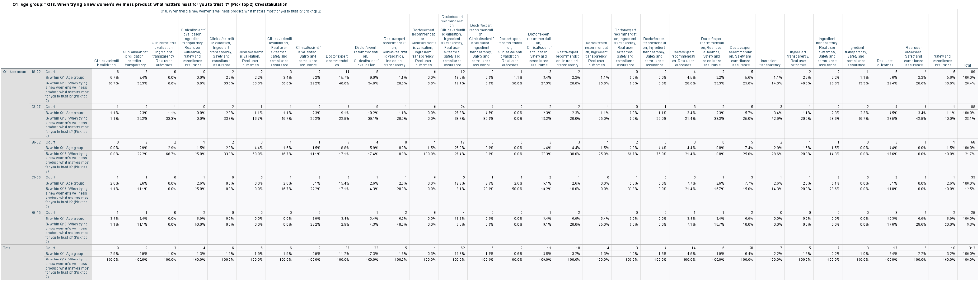

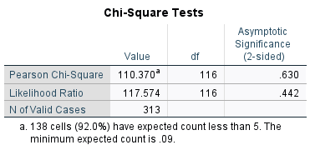

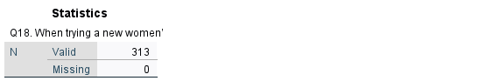

Frequence Distribution: Trust Factor
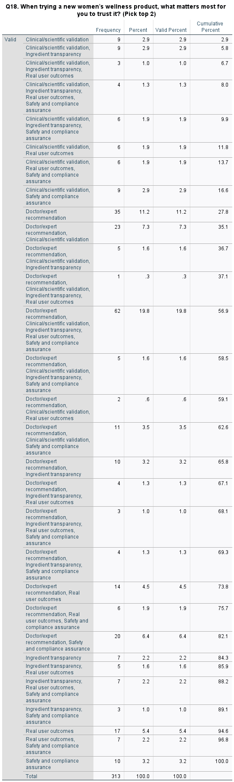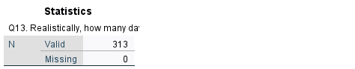

Frequency Distribution: Daily Routine

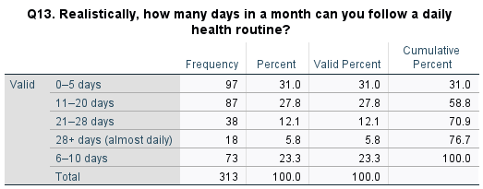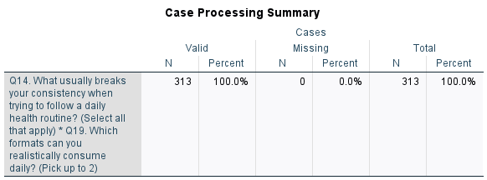

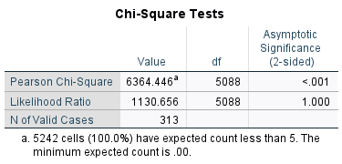
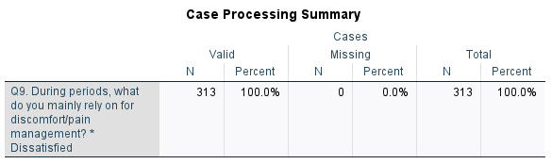

Cross Tabulation: Reliability x Dissatisfaction
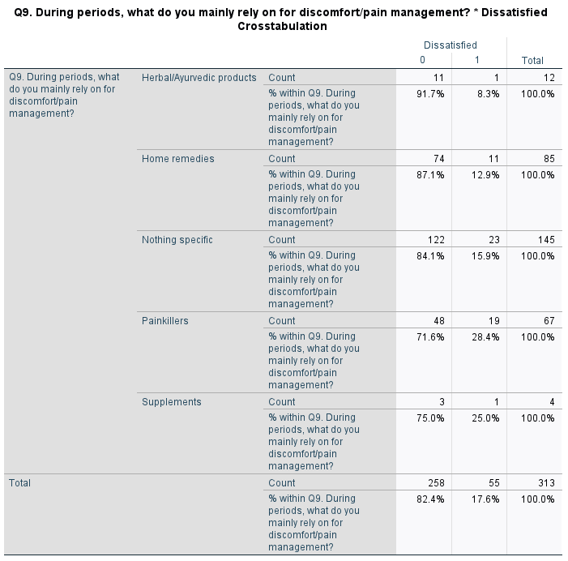
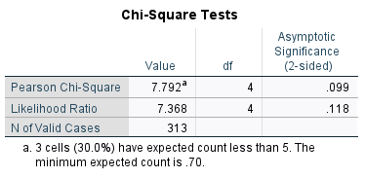
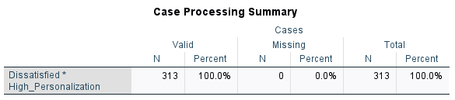

Cross-Tabulation: Dissatisfaction x Personalization

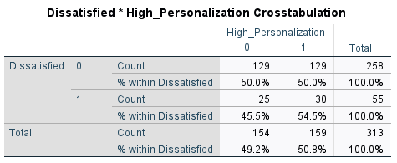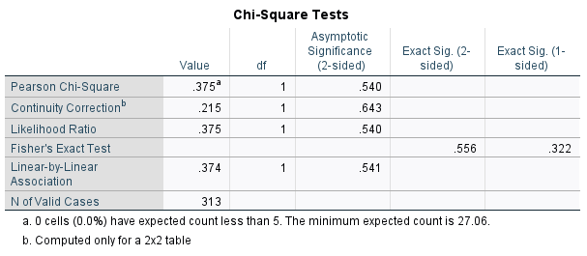

Frequency Distribution: Clinical Scientific Validation

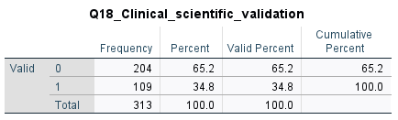

Frequency Distribution: Ingredient Transparency

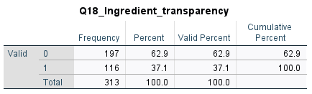

Frequency Distribution: Real User Outcomes

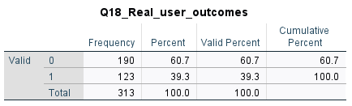

Frequency Distribution: Safety and Compliance Assurance

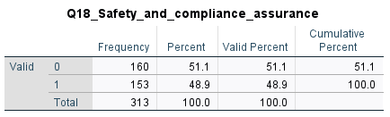

Frequency Distribution: Doctor Expert Recommendation

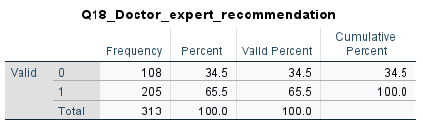
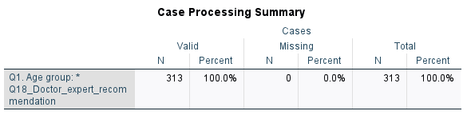

Cross-Tabulation: Age x Doctor Expert Recommendation



